[Email address]



Name : Anika Tahseen Maliha

Roll:01-054-07

Batch :54

Comprehensive Project Using Microsoft word,Excel and Powerpoint

Appetizer Restaurant & café

Table of Contents

1 About my resturant: 2

2 Our mission 2

3 Services we provide: 2

3.1 Dine-In Experience: 3

3.2 Takeaway & Delivery: 3

3.3 Catering Services: 3

3.4 Sustainable Practices: 3

3.5 Special Events & Promotions: 3

3.6 Family-Friendly Amenities: 3

4 Customers journey at Appetizer restaurant : 4

5 Statistical data : 5

6 Food categories : 6

7 Most Popular Menu Categories at Appetizer Restaurant 6

# About my resturant:

Welcome to Appetizer Restaurant, where culinary excellence meets a warm and inviting atmosphere. Established in 2020 in Dumki , Patuakhali .Our restaurant is dedicated to providing an unforgettable dining experience for all our guests. At Appetizer Restaurant, we pride ourselves on our diverse menu that showcases the best of [Cuisine Type], crafted with fresh, locally sourced ingredients. Our chefs blend traditional recipes with innovative techniques, ensuring each dish is a delightful journey for your taste buds. Whether you’re here for a casual meal with friends, a romantic dinner, or a special celebration, our Restaurant offers the perfect setting.

# Our mission

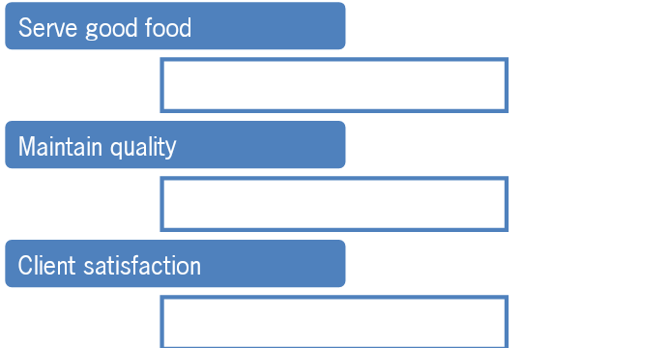

# Services we provide:

## Dine-In Experience:

*Cozy and eco-friendly interiors with a warm ambiance. oCo*

*urteous staff offering personalized service.*

## Takeaway & Delivery:

oConvenient and eco-conscious packaging for all orders.

## Catering Services:

oCustomized catering for parties, corporate events, and celebrations.

## Sustainable Practices:

oUse of biodegradable materials and local, organic ingredients.

oMinimal food waste policies with donations of excess food to local charities.

## Special Events & Promotions:

oWeekly themed nights (Desi Fridays, Chinese Saturdays).

oSeasonal menus and festive specials.

## Family-Friendly Amenities:

oKids’ play zone and special kids’ menu.

oPrivate dining rooms for intimate gatherings.

# Customers journey at Appetizer restaurant :

Click or tap here to enter text.

ENTER

GET A MENU

CHOOSE FOOD

PLACE FOOD

Wait for food

Eat food

Pay the bill

Exit

# Statistical data :

|  |  |  |  |  |  |  |  |
| --- | --- | --- | --- | --- | --- | --- | --- |
| **Month** | **Sales (BDT)** | **Food Cost (BDT)** | **Labor Cost (BDT)** | **Utilities Cost (BDT)** | **Other Expenses (BDT)** | **Total Cost (BDT)** | **Net Profit (BDT)** |
| **January** | 1,200,000 | 400,000 | 250,000 | 100,000 | 50,000 | 800,000 | 400,000 |
| **February** | 1,100,000 | 380,000 | 240,000 | 90,000 | 55,000 | 765,000 | 335,000 |
| **March** | 1,300,000 | 420,000 | 260,000 | 95,000 | 60,000 | 835,000 | 465,000 |
| **April** | 1,150,000 | 400,000 | 250,000 | 110,000 | 65,000 | 825,000 | 325,000 |
| **May** | 1,250,000 | 410,000 | 270,000 | 105,000 | 60,000 | 845,000 | 405,000 |
| **June** | 1,100,000 | 390,000 | 240,000 | 100,000 | 50,000 | 780,000 | 320,000 |
| **July** | 1,300,000 | 430,000 | 260,000 | 110,000 | 55,000 | 855,000 | 445,000 |
| **August** | 1,200,000 | 400,000 | 250,000 | 95,000 | 60,000 | 805,000 | 395,000 |
| **September** | 1,250,000 | 420,000 | 260,000 | 105,000 | 65,000 | 850,000 | 400,000 |
| **October** | 1,350,000 | 440,000 | 270,000 | 110,000 | 70,000 | 890,000 | 460,000 |
| **November** | 1,200,000 | 410,000 | 250,000 | 95,000 | 55,000 | 810,000 | 390,000 |
| **December** | 1,500,000 | 450,000 | 280,000 | 120,000 | 75,000 | 925,000 | 575,00 |

|  |  |
| --- | --- |
|  |  |

# Food categories :

# Most Popular Menu Categories at Appetizer Restaurant

# 